# Proposal

1. **Project Deliver**

* Total Hours: **520 hours** (Approximate 3 months)
* *Webpage Development - 252 hours*
* *Functionalities Development - 268 hours*
* Human Resources: **3 developers**
* Free test run duration: **1 month** (After Website Fully Developed)
* Total Web Pages: **45 pages**
* Functionalities:
* *User Management*
* *Product Management*
* *Inventory Management*
* *Order Management*
* *Cart Management*
* *Payment Gateway Integration*
* *Dashboard Monitoring*
* *Contact*

1. **Purchasing Plan**

* Upfront cost: **RM 14,500**
* Annual renewal fee: **RM 687**
* **Free 3 years renewal fee**

1. **Cost on Facilities**

* Domain name: **RM 50**/annual (affected by popularity of domain name）
* Hosting Server: **RM 99**/annual (upgradable as the user utilization increase)
* Payment Gateway: eGHL

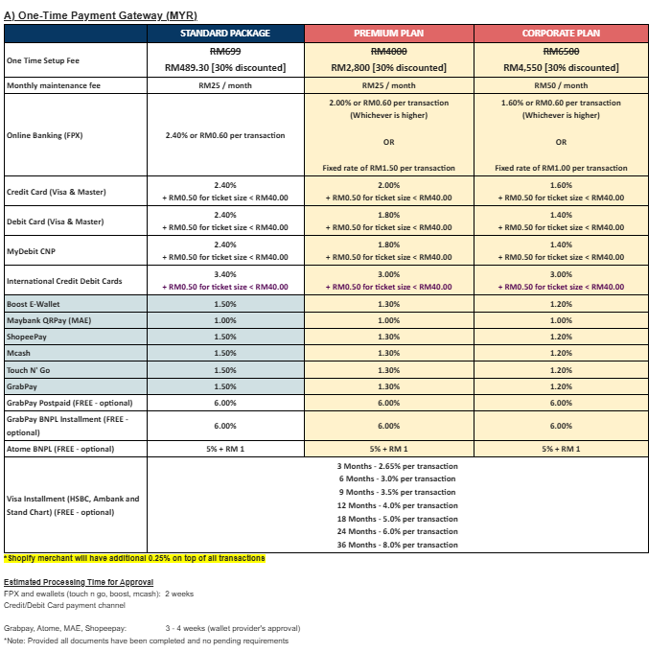

1. **User Scenarios**

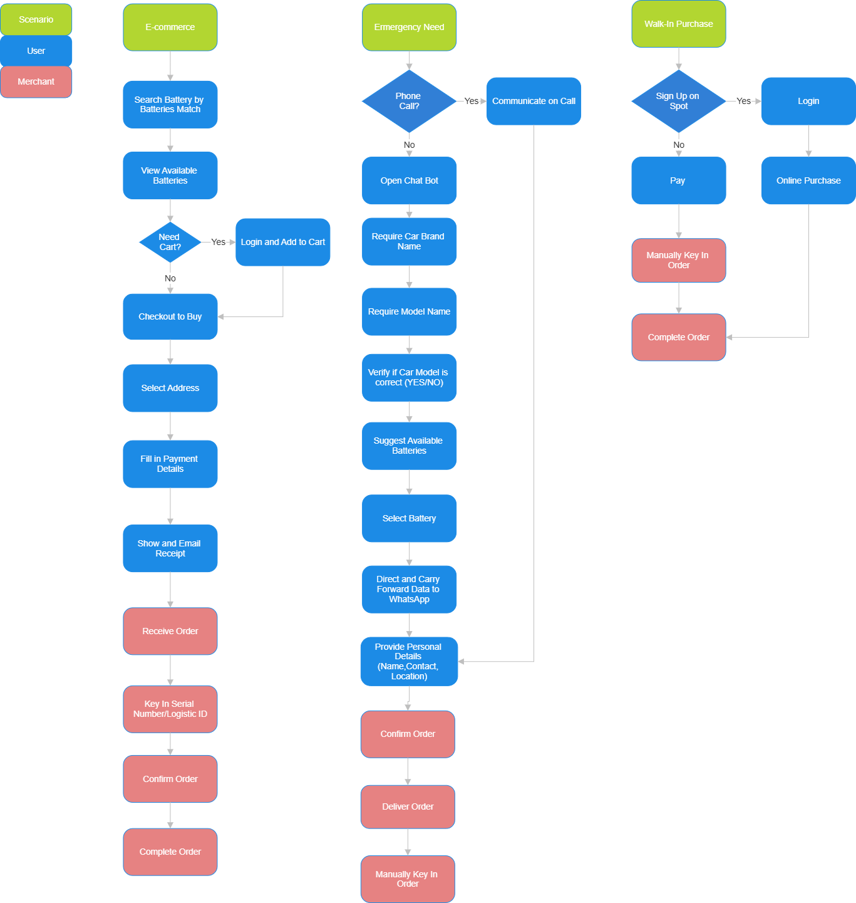

**Deliver Order**

**Key In Order**

**Search**